Name………………………………………………. Contact email: ………………………………………………………..
Name………………………………………………. Contact email: ………………………………………………………..
Name………………………………………………. Contact email: ………………………………………………………..
Name………………………………………………. Contact email: ………………………………………………………..
Name………………………………………………. Contact email: ………………………………………………………..
Name………………………………………………. Contact email: ………………………………………………………..
Name………………………………………………. Contact email: ………………………………………………………..
Name………………………………………………. Contact email: ………………………………………………………..
Name………………………………………………. Contact email: ………………………………………………………..
Name………………………………………………. Contact email: ………………………………………………………..
Name………………………………………………. Contact email: ………………………………………………………..
Name………………………………………………. Contact email: ………………………………………………………..
If you are interested in taking the 4 week challenge for Beavers or Scouts, please leave your details below and we will be in touch to plan some dates with you.
Name………………………………………………. Contact email: ………………………………………………………..
Name………………………………………………. Contact email: ………………………………………………………..
Name………………………………………………. Contact email: ………………………………………………………..
Name………………………………………………. Contact email: ………………………………………………………..
Name………………………………………………. Contact email: ………………………………………………………..
Name………………………………………………. Contact email: ………………………………………………………..
Name………………………………………………. Contact email: ………………………………………………………..
Name………………………………………………. Contact email: ………………………………………………………..
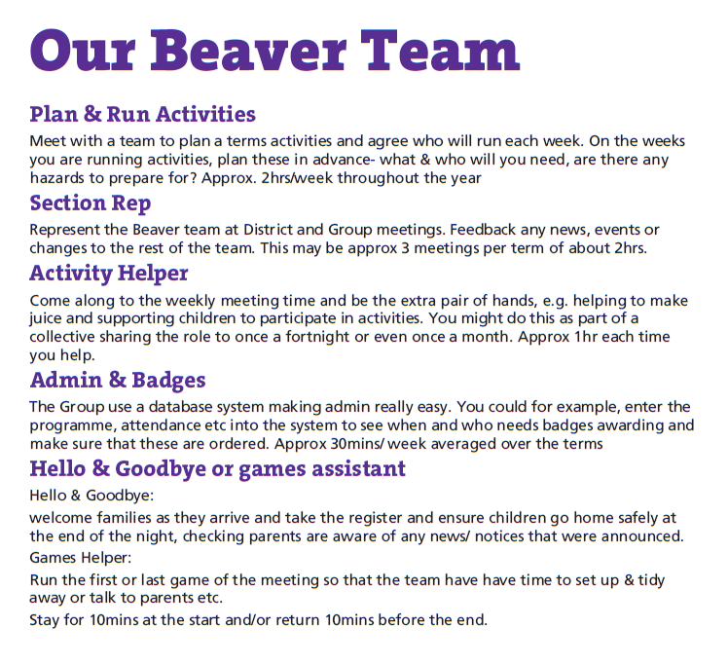
Name…………………………………… Task:……………………………... Email: …………………………………………………
Name…………………………………… Task:……………………………... Email: …………………………………………………
Name…………………………………… Task:……………………………... Email: …………………………………………………
Name…………………………………… Task:……………………………... Email: …………………………………………………
Name…………………………………… Task:……………………………... Email: …………………………………………………
Name…………………………………… Task:……………………………... Email: …………………………………………………
Name…………………………………… Task:……………………………... Email: …………………………………………………
Name…………………………………… Task:……………………………... Email: …………………………………………………
Name…………………………………… Task:……………………………... Email: …………………………………………………
Name…………………………………… Task:……………………………... Email: …………………………………………………
Name…………………………………… Task:……………………………... Email: …………………………………………………
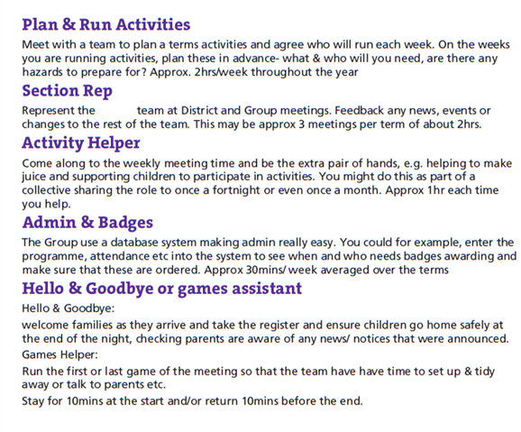Name…………………………………… Task:……………………………... Email: …………………………………………………
Name…………………………………… Task:……………………………... Email: …………………………………………………
Name…………………………………… Task:……………………………... Email: …………………………………………………
Name…………………………………… Task:……………………………... Email: …………………………………………………
Name…………………………………… Task:……………………………... Email: …………………………………………………
Name…………………………………… Task:……………………………... Email: …………………………………………………
Name…………………………………… Task:……………………………... Email: …………………………………………………
Name…………………………………… Task:……………………………... Email: …………………………………………………
Name…………………………………… Task:……………………………... Email: …………………………………………………
Name…………………………………… Task:……………………………... Email: …………………………………………………
Name…………………………………… Task:……………………………... Email: …………………………………………………
Name…………………………………… Task:……………………………... Email: …………………………………………………
Name…………………………………… Task:……………………………... Email: …………………………………………………
Name…………………………………… Task:……………………………... Email: …………………………………………………
Name…………………………………… Task:……………………………... Email: …………………………………………………
Name…………………………………… Task:……………………………... Email: …………………………………………………
Name…………………………………… Task:……………………………... Email: …………………………………………………
Name…………………………………… Task:……………………………... Email: …………………………………………………
Name…………………………………… Task:……………………………... Email: …………………………………………………
Name…………………………………… Task:……………………………... Email: …………………………………………………
Name…………………………………… Task:……………………………... Email: …………………………………………………
Name…………………………………… Task:……………………………... Email: …………………………………………………

